**Thermometer**

## **Step 1: Make it**

### **What is it?**

Show how hot or cold your micro:bit is using the built-in temperature sensor.

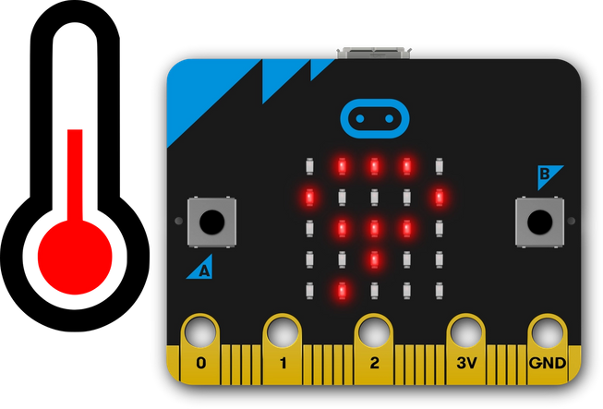

### **How it works**

* This program shows how hot or cold your micro:bit is by taking a reading from the temperature sensor in its processor or CPU (central processing unit).
* The processor’s temperature is a fairly good approximation of the temperature around you in °C (Celsius).
* In this program, when you press input button A, the micro:bit displays the processor’s current temperature on its LED display output.
* Take the micro:bit into warmer and colder places and see how the temperature readings change.

### **What you need**

* micro:bit (or MakeCode simulator)
* MakeCode or Python editor
* battery pack (optional)
* a source of heat or cooling, like a fan, if you want to see the temperature change quickly (optional)

### **Step 2: Code it**

## **Step 3: Improve it**

* Compare the reading with another thermometer. How accurate is the micro:bit? Do you need to modify the micro:bit reading to get the air temperature?
* Convert the temperature to Fahrenheit or Kelvin.
* Use radio to make a remote sensor sending temperature readings to another micro:bit, for example from outside to inside. You could make an indoor / outdoor thermometer this way.